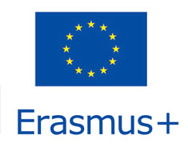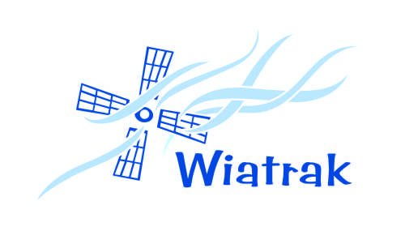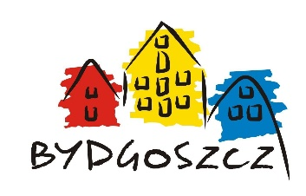

**EUROBAKCYARDS 8**

**EVS: 15.07-01.09.2018**

**Place: Bydgoszcz, Poland**

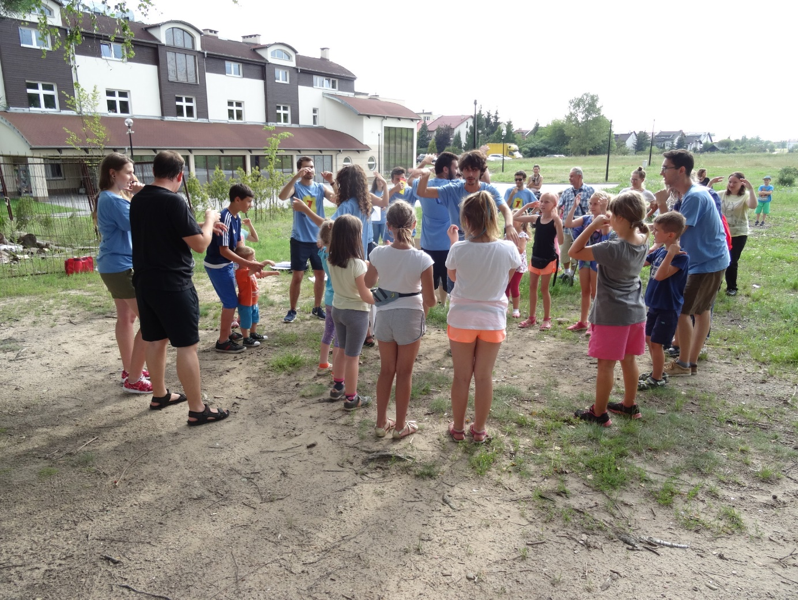



Welcome to our EVS family

Dear Volunteer!

We are already waiting for you. We are happy that you will honour us with your presence. We believe that your stay among us will bring us and our children a lot of joy.

We are also happy that thanks to you we will get to know the culture and traditions  
that prevail in your country. We hope that you will return to your home enriched with a new and invaluable experience in your life.

We have prepared infopack because we want to explain you in a few words what  
is EVS. We want you to know something about our country, town you are going to live  
and “Wiatrak” Foundation. We are going to give you also all the details about your travel.

We hope it will be useful for you to give you an idea about how it is like.  
Of course, we will be always available to help you.



What is about?

The theme of the project is a series of cultural and educational meetings conducted  
in the open air by European volunteers along with national volunteers.

During activities with children and young people we want to promote different cultures of the European Union.

Our goal is also to reduce language and cultural barriers, combat stereotypes related  
to foreign culture, promote active recreation and volunteering, especially international.

The task of volunteers is to organize and conduct meetings with children and teenagers in the backyards of Bydgoszcz. You will work in groups, prepare for the presentation of your culture, and animate games and activities. The presentations and games will be prepared hand-made from different materials which we will provide.



ACCOMMODATION

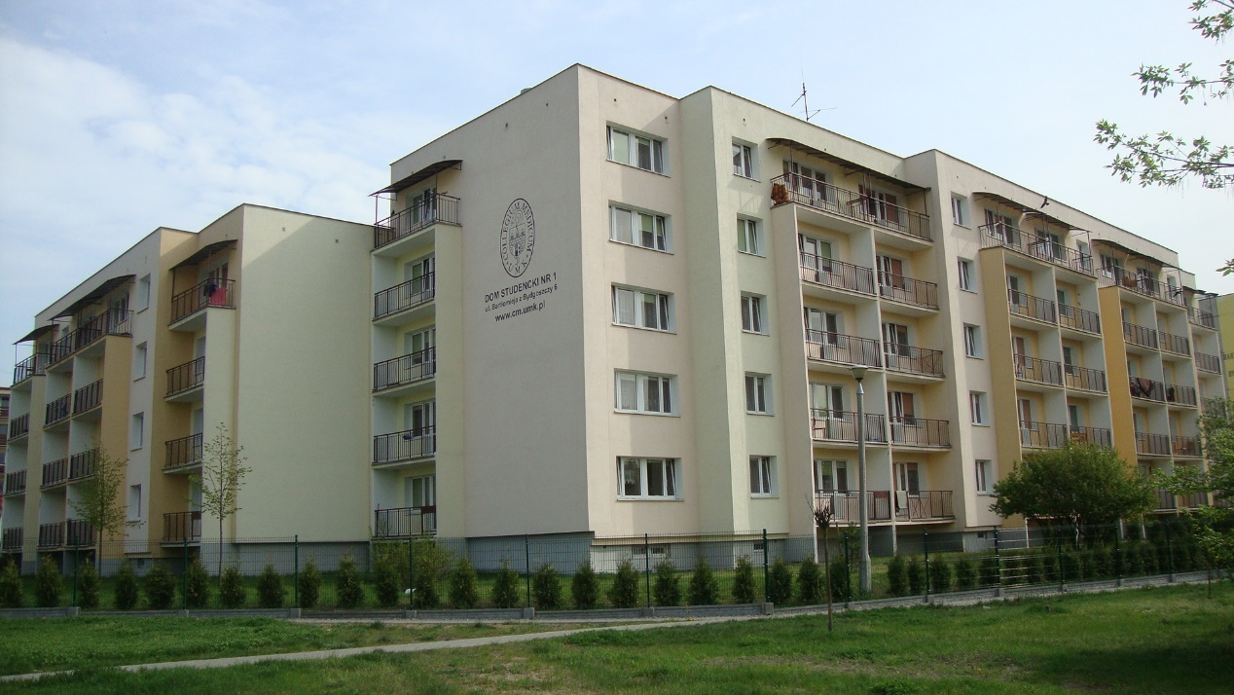

You will live in the student’s residence near “Wiatrak” Foundation in a shared room with other volunteers. The apartment is fully-equipped e.g. kitchen equipment, pillows, blankets, bedclothes.

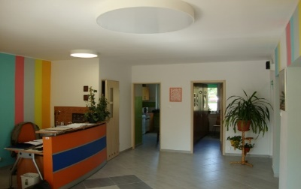 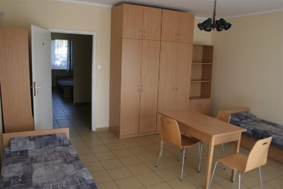 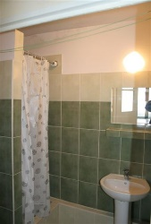 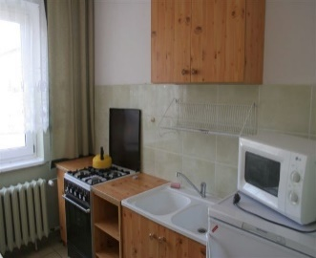

The residence is located in Fordon, it is a residential district not in the city centre but taking the tram you can reach the centre in 30 minutes. Close to you there are many supermarkets, small shops, bus stops, beautiful nature and your working place. In the residence there is no wifi. But there is cable internet (the dorm provides the cables). If you want to have the internet in your rooms, it’s best to take a laptop with you In “Wiatrak” Foundation building there is wifi everywhere-so you are welcome to use it. ☺

**The only things which you need to take with you are towels and hairdryers.**



Your place is next to the bus stop named **Twardzickiego/Łochowskiego**. If you like buying in big supermarket in a few stops you can go to Polo and you can use the bus nr 69  
to get to Auchan, Lidl, Carrefour. Also, with nr 69, 83 and 89 bus you can go to a mall in Fordon called Galeria Pomorska where you can find Zara, Stradivarius, H&M, Croop….

Food prices in Poland are average, for example, a bread, milk costs about 3PLN, butter 6PLN, coffee 10PLN (the EURO’S medium course with 25th june is 4,3242 PLN). At our foundation there is an art café and restaurant “Młynek”. Here soup, for example, costs 8PLN, main course costs about 20PLN. **Volunteers have 10 percentage**.

Nearby, at 10 minutes from your place, you have also tram stops: **Przylesie**and **Akademicka/Kaliskiego (UTP)**. From there you can go by tram to the centre in 20 minutes. The app Jakdojade is highly recommended to check the transport options as you can see in the image below.

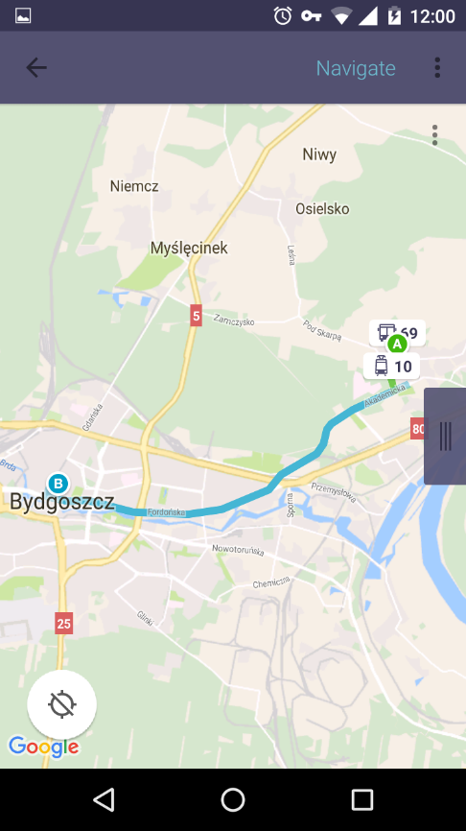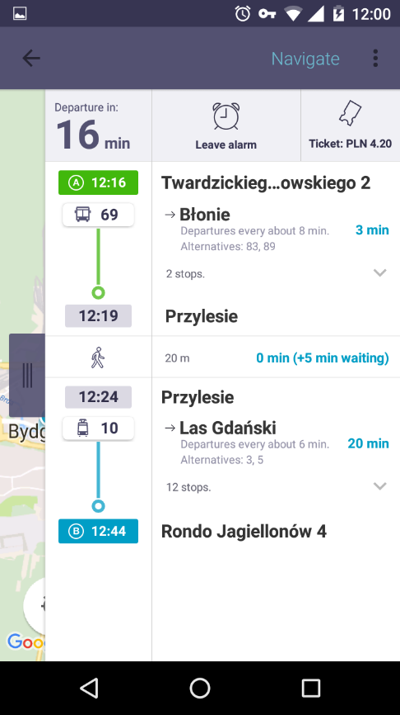

Train is the fastest and easiest way to travel around Poland. You can follow the link  
to check and arrange your travelling (<http://rozklad-pkp.pl/bin/query.exe/en>).

Other option, cheaper than train is bus. You can find your connecting in this link: <https://www.e-podroznik.pl> or <http://www.pks.bydgoszcz.pl/>



TRAVEL TO POLAND

You can come to Poland by air. Nearby Bydgoszcz is an airport in Warsaw-Okęcie, Gdańsk or Poznań. In Bydgoszcz is also an airport but only serves a few international flights.

TRAVEL FROM AIRPORT IN WARSAW TO BYDGOSZCZ

Once in Warsaw airport you should take a bus nr 175 or N32 (night bus) to Warszawa Centralna (Warsaw Central Station). The bus stop, where you arrive is called Dw. Centralny 01. You need to cross the street and enter the main building of the train station (<https://www.lotnisko-chopina.pl/en/public-transport.html>,). Please remember to buy a ticket at the station in the ticket machine or kiosk and validate it inside the vehicle. On the night you can buy a ticket in the bus, from the driver.

On Warsaw Central Station you should take a train Intercity  
to Bydgoszcz Wschód Station or Bydgoszcz Główna (Bydgoszcz Central Station). You must buy a ticket at the station or electronically. But if you buy electronic tickets, please remember  
to have in invoice!!! (<https://www.intercity.pl/en/>)

TRAVEL FROM AIRPORT IN GDAŃSK TO BYDGOSZCZ

Once in Gdańsk airport you can go by bus with Gdn express company directly  
to Bydgoszcz. You need to buy a ticket on the bus for PLN68 (about 16 Euro’s).

TRAVEL FROM AIRPORT POZNAŃ TO BYDGOSZCZ

Once in Poznań airport you should take a bus nr 59, 48, 242 (night bus) to Poznań Główny Station (<https://www.ztm.poznan.pl/en/>). You must buy a ticket at the station in the ticket machine, kiosk.

Then in Poznań Główny Station you should take a train to Bydgoszcz Główna Station. You must buy a ticket at the station in kiosk.

Hier is a link to good website that may help you find connections to Bydgoszcz:  
<https://www.e-podroznik.pl>

Please remember to keep **ALL THE ORIGINAL TICKETS AND BOARDING PASSES**. If you can't provide it, we will not be able to reimburse your travel costs!!!!

**AT THE STATION IN BYDGOSZCZ WILL BE A MENTOR WAIT FOR YOU.**



NOW A FEW WORDS  
ABOUT POLAND, BYDGOSZCZ AND OUR FUNDATION



POLAND

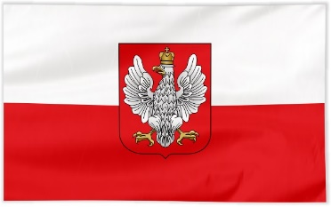

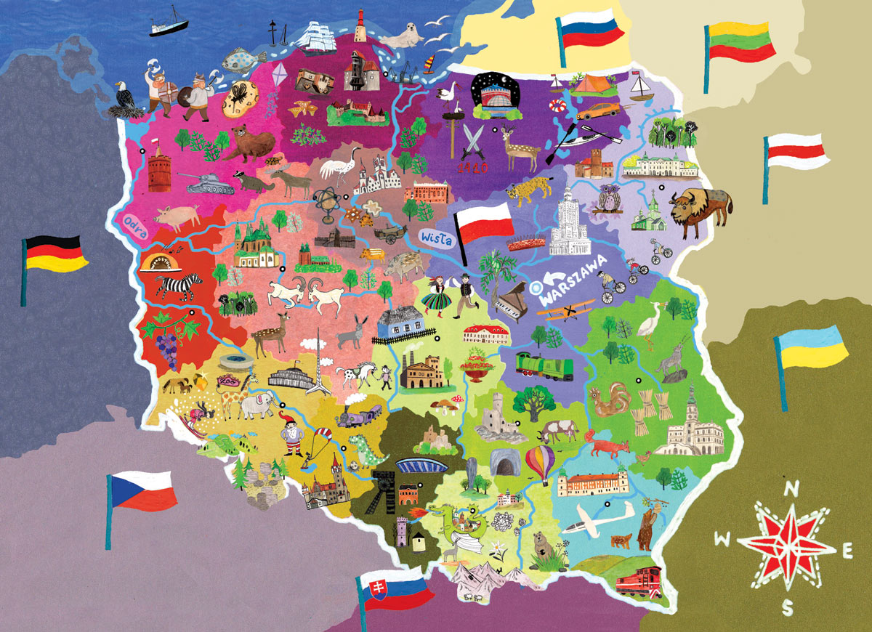The Republic of Poland is a beautiful country in central Europe, bordered by Germany, the Czech Republic, Slovakia, Ukraine, Belarus, Lithuania, Russian Federation (Kaliningrad Oblast – a Russian Enclave) and Baltic Sea. The total area of Poland is 312,679 square kilometres (120,726 sq mi), making it the 71st largest country in the world and the 9th largest in Europe. The current president of Poland is Andrzej Duda.

With a population of over 38.4 million people, Poland is the 34th most populous country in the world,the sixth most populous member of the European Union.

Some big towns in Poland are Warsaw – the capital, Kraków – previous capital of Poland, , Gdańsk – on the Baltic Sea, Zakopane – in mountains Tatry, Toruń – birthplacy of Mikołaj Kopernik, Wadowice – birthplacy of Pope Sainth John Paul II, Wroclaw, Katowice, Lublin, Poznań, etc.



BYDGOSZCZ

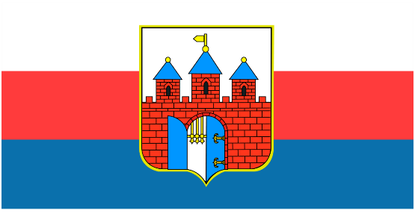

Bydgoszcz is a city located in northern Poland, on the Brda and Vistula rivers. With a city population of 352,313 (December 2017), and an urban agglomeration with more than 470,000 inhabitants, Bydgoszcz is the 8th-largest city in Poland. It has been the seat ofBydgoszcz countryand the co-capital, with Toruń.

Bydgoszcz is the seat of Kazimierz Wielki University**,** University of Technology and Life Sciences and a conservatory. The oldest building in the city is the Church of St Martin and Nicolaus, commonly known as Farna Church.

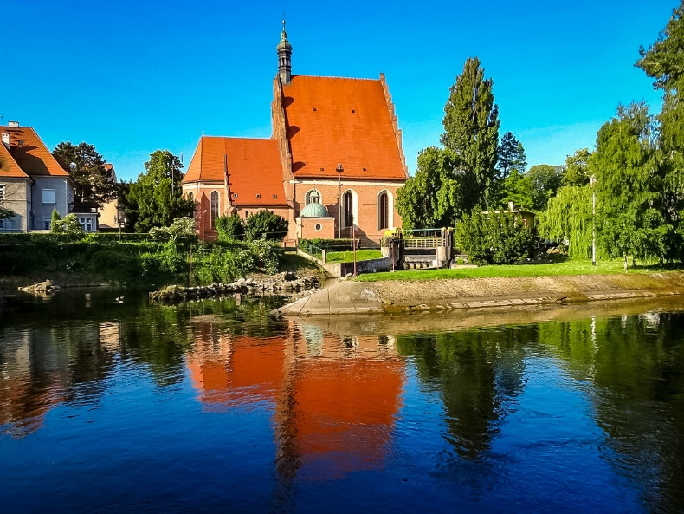



Bydgoszcz is an important sports centre. At the stadium “Zawisza” in 2016 had occurred world championship in athletics U20.

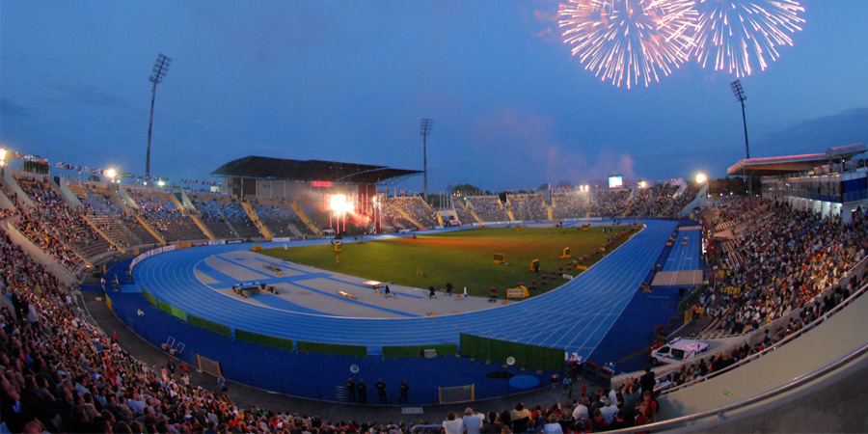

The symbol of Bydgoszcz are Granaries referring to the city’s commercial tradition related to inland navigation.

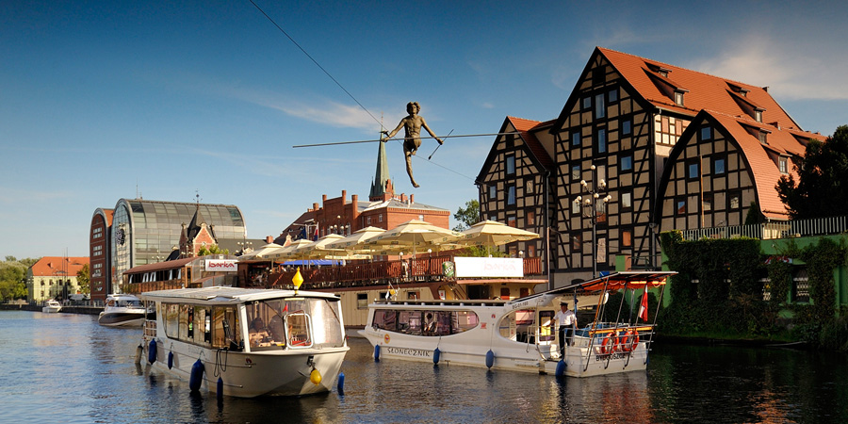



“WIATRAK” FOUNDATION

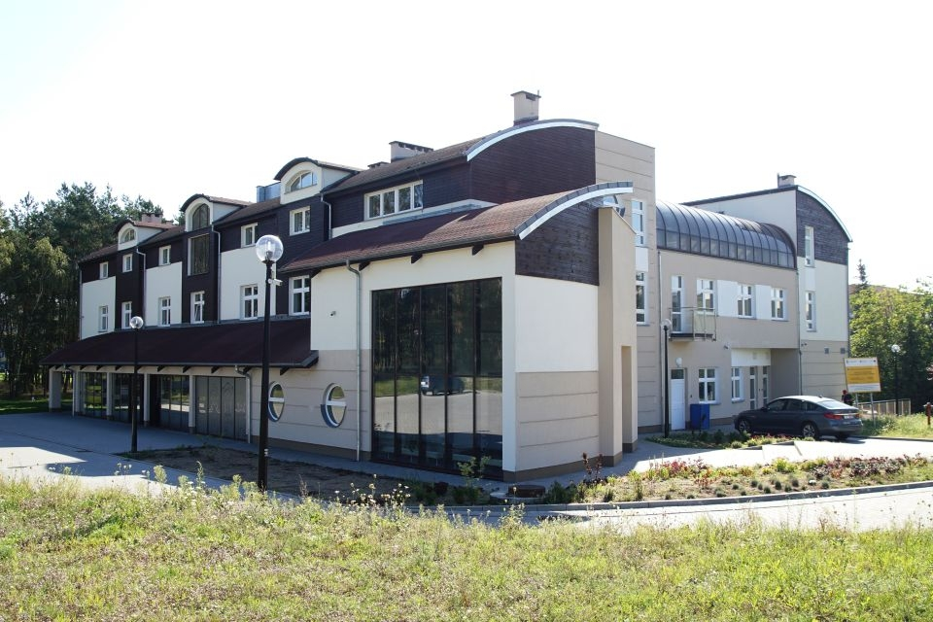

The “Wiatrak” Foundation is a public benefit organization whose main idea is implement to live the teachings of Saint John Paul II, which talks about human development on four levels: physical, mental, intellectual and spiritual.

Classes, workshops, meetings and other events take place in the unique interiors of the Dom Jubileuszowy Jana Pawła II (Jubilee House of John Paul II) at 7 Bołtucia Street next to the Parish of Our Lady Queen of Martyrs. Interior of this home you can see on the site: http://wiatrak.org.pl/dom-jubileuszowy-jana-pawla-ii/

In “Wiatrak” we create a space where every person, regardless of age, health or life situation, can expand his knowledge, develop talents and discover the joy of being a gift for another human being.

The activity of “Wiatrak” we can be divided into five main segments: education, culture, social integration, clinic and international cooperation.



CONTACT

We will give you polish SIM cards for your mobile phone. Please make sure your phone works with the SIM cards of other mobile operators.

If you have any problem during the journey you can contact us by phone.

Anna Araszkiewicz: **+48 799 993 239**

Maciej Brząkała: **+48 504 712 446**

***Let’s start your adventure in Bydgoszcz!***

